**Simple Queries Section A:**

1. **List the details of all the employees**

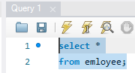

1. **List the name, job, and hire date of all the employees**

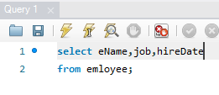

1. **List all the details of the department**

1. **List the name and the location of all departments**

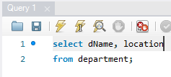

1. **List all details of employees whose salary is greater than 1500**

1. **List all the department details where location is Dallas**

1. **List the name, job, and the salary of employees from department no 20**

1. **List all the details of the departments not from New York**

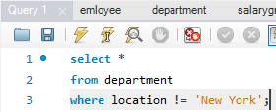

1. **List the name, job, and salary of all the employees whose salary is greater than 2000**

1. **and working for the department no 30**

1. **List the name, number, job, and the salary of the employees who are working for the department no 20 or those who are earning a salary 2500**

**Simple Queries Section B:**

1. **List all the employees whose salary is between 1000 and 2000. Show employee name, department and salary**

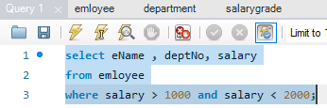

1. **Display all the different types of occupations**

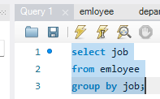

1. **List all details of the employees in department 10 and 30**

1. **Display all employees who were recruited during 1983, giving their name, department and hire date**

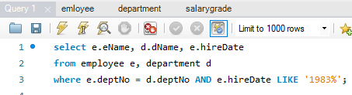

1. **List names and jobs of all clerks in department 20**

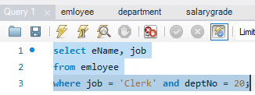

1. **List the employees whose names have TH or LL in the name**

1. **List Department Numbers and names in department name order**

1. **List all the information in a table called Salary Grade**

**Simple Queries Section C:**

1. **Display Employee name, location and department of those whose salary is greater**

**than 1500**

1. **Produce a list which will show the grade that each employee is in (Display**

**Employee name, Job, Salary and the Grade)**

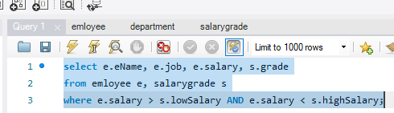

1. **List Employee name, Job, Salary and Grade for those in Grade 3**

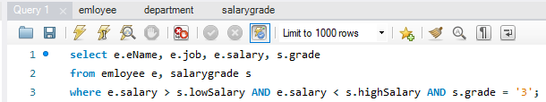

1. **As (b) above but also display their Department name, in descending order of their**

**Salary grade**

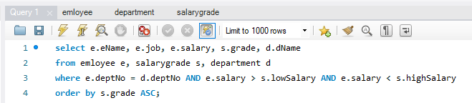

1. **Find the name and salary of employees in Dallas**

